Appendix 1: Social Media “How to” Kit
Join us this January to promote National Birth Defects Prevention Month using your social media networks. Use this resource to raise awareness about #Best4YouBest4Baby and join the conversation about preventing birth defects.

In this appendix, we provide suggestions for using various social media platforms to promote National Birth Defects Prevention Month, such as example posts. Also included are resources on evaluation and useful tools.

Facebook
Facebook is the largest social media platform, with about 1.59 billion daily active users.

Audience
- 53% of Facebook users are women, and 47% are men.
- 79% of all adults between 18-49 years old use Facebook.
- Individuals who upload photos and post personal status updates, as well as public-facing Organizations- non-profits, businesses, and government organizations such as the CDC.

Best Practices
- Posts can be 420 characters or less, plus a web link. Shorter lengths are ideal.
- Posts should be action-oriented, include a specific call to action. Should also include a link to a web page, photo or video.

Tips
Planning how to take care of your health conditions before you become pregnant can help keep you and your developing baby healthy!
- Use a casual, but professional tone.
- Like National Birth Defects Prevention
Network’s page on Facebook. Share and comment.
- Tag National Birth Defects Prevention Network in your own posts.
- Share the “Best for You. Best for Baby.” badge, CDC social media graphics, or change your profile photo to any of these images!

Twitter
Twitter is an online news and social networking service with about 330 million users.

Audience
- An equal amount of men and women use Twitter.
- 38% of Americans ages 18-29 years use Twitter.
- Individuals post personal mini blogs, and stay up-to-date with news and culture.
- Businesses and organizations use Twitter for marketing and as an educational tool.

Best Practices
- Limits posts to 280 characters per tweet (including spaces).
- Users identify themselves by their username (e.g. @NBDPN).
- Share messages from other users by retweeting those that are relevant.
- Write concise tweets and limit abbreviations.
- Include images + videos.
- Tweets with images are 150% more likely to get retweets than text-only tweets.
- Videos are 6x more likely to be retweeted than photos and 3x more than GIFs.
- Use hashtags to help discovery.
- 1-2 hashtags is ideal.
- Do research before jumping on trending hashtags. Join the conversations when it’s relevant.

Tips
Thinking about having a #baby? @NBDPN recommends all women of childbearing age consume 400 micrograms of #folic acid daily. #Best4YouBest4Baby
- A “tweet” is the message you post and a “handle” is the username.
- Use the character counting tool in Microsoft Word to calculate the number of characters in a draft tweet.
- Follow @NBDPN and @CDC_NCBDDD on Twitter. Retweet, favorite, and comment.
- Use the #Best4YouBest4Baby hashtag when sharing information, resources, photos or your own experiences.
- Ask a question, highlight a key statistic, or provide a specific call to action.
- The best time to tweet is around 3pm if you hope to engage with businesses. If you want more general public engagement, it’s best to tweet outside of working hours.

Instagram
Instagram is a social media platform made for sharing photos and videos, with about 800 million users.

Audience
- 37% of US adults use Instagram, consisting mainly of 18-49 year-olds.
- Instagram usage is 12% greater among women versus men.
- Pew Research Center reports that, in 2018, about 67% of Americans between 18-29 year olds and 47% of 30-49 year olds use Instagram.
- Individuals share their best photos or videos and follow people and groups with common interests.
- Organizations use Instagram to bring awareness and educate through visuals.

Best Practices
- Post regularly and during optimal times to keep your audience engaged.
- Use relevant hashtags generously.
- Ask questions in your captions that people will be eager to answer.
- Include faces – photos with faces get more engagement.
- Use the caption to provide context for your visuals, but keep it short and use plain language.

Tips
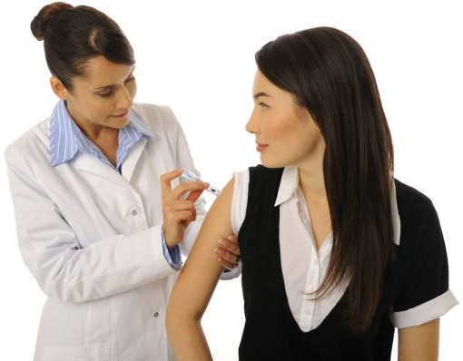
- Make your profile public to allow for more followers.
Protect yourself and your baby by getting your #flu shot every year! #Best4YouBest4Baby #pregnancy
- Encourage users to submit their content ideas.
- Follow @CDCgov and @NBDPN.
- Post photos of best practices for you and your baby and incorporate the hashtag #Best4YouBest4Baby.
- Share your own story of how birth defects affect you. Tag photos with @NBDPN.
- Note that links in Instagram captions are not clickable. Consider creating custom bitly link.

Evaluation
To understand and measure your social media “reach,” we’ve gathered some resources to help track your social media presence.
- Overview of social media metrics
- Facebook
o Page Insights allows you to view a detailed breakdown of important metrics including, total actions on a page, views, likes, followers and more. Facebook page insights also allows you to view the metrics from other pages you watch as well as the demographics of the individuals who are watching your page.
- Twitter
o Twitter Analytics allows you to view a summary of metrics and highlights of your activity by month. Metrics in Twitter Analytics include number of tweets posted, tweet impressions, profile visits, mentions, followers, and tweets linking to you and more. This tool also allows you to view a breakdown of the audience demographics by lifestyle, consumer behavior and mobile footprint.
- Instagram
- Instagram Insights are only available to those with business accounts. In order to create a business profile on Instagram, a Facebook account must be linked.
- Instagram Insights provide information on your followers, when they are online, likes, comments, saves, profile visits, follows, and more.

Useful tools
Here are some useful tools to help manage your social media postings.
- Hootsuite – A free tool that allows you to schedule in advance across any social media platform.
- IFTTT – “If this, then that” is free and allows you to combine different tools to create individual sets of instructions. For example, every time you create an Instagram post, you can tell IFTTT to send a tweet.
- Bitly – Allows you to shorten any URL to fit on any social media platform.
- Canva – Create graphics for social media through professionally designed layouts for any platform.
- Adobe Spark – Create graphics and video stories from templates for any platform online or through a mobile app.

References
- CDC Social Media Tools:
  - https://www.cdc.gov/socialmedia/tools
  - https://www.cdc.gov/socialmedia/tools/guidelines/pdf/socialmediatoolkit_bm.pdf
  - https://www.cdc.gov/socialmedia/tools/guidelines/pdf/GuidetoWritingforSocialMedia.pdf

- Social media demographics

- Pew Research Center

- Best times to post on social media

