● Fact Sheet for Policy Makers ●
Birth Defects Tracking, Research & Prevention
Tracking where and when birth defects occur and who they affect is a first step in preventing them. Tracking and research help us understand if the number of birth defects is increasing or decreasing over time, investigate possible causes, expand our understanding of preventive measures, and plan for health and education services for families of children with special needs.

Birth Defects: Common, Costly, and Critical

Common | Costly | Critical
1 in 33 babies | $2.6 billion | 1 in 5 deaths
Birth defects affect 1 in every 33 babies born in the United States. [Insert state numbers] | Each year, total hospital costs for U.S. children and adults exceed $2.6 billion. | Birth defects cause 1 in every 5 deaths among babies in their first year of life.
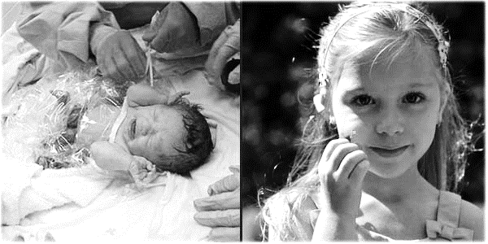
Real Families, Real Stories
Meet Ashley. She was born with gastroschisis, a birth defect which caused her intestines to be located on the outside of her body at birth. The beginning of her life was filled with surgeries and tests, setbacks and worry. Her mother, Kayte, says, “Ashley has a resiliency that other kids her age don’t possess… Although her life was initially filled with challenges, Ashley is blossoming into a remarkable young girl who has inspired countless other families with her story.” Ashley represents 1 in every 33 babies born in the United States.

Importance of Birth Defects Tracking and Research
The value of birth defects tracking programs on clinical and public health research cannot be overstated. This work has revolutionized the way researchers, clinicians, and healthcare professionals approach, treat, and manage babies affected by birth defects. Tracking and research help us understand if the number of birth defects is increasing or decreasing over time, investigate possible causes, expand our understanding of preventive measures, and plan for health and education services for families of children with special needs. Identifying birth defects at a state level also strengthens public health officials’ ability to estimate prevalence and evaluate risk factors that are most important to their community.

<STATE> Birth Defects Tracking System
Since <YEAR>, the <BIRTH DEFECT TRACKING PROGRAM (BDTP)> has monitored the prevalence of birth defects in <STATE>. The <BDTP> is a statewide, population-based surveillance program with information on approximately <STATE SPECIFIC NUMBER> babies born with specific birth defects. The <BDTP> was established to identify and describe the patterns and trends of birth defects in <STATE>, provide education and outreach, investigate potential causes, and respond to community concerns about possible clusters of birth defects. These data are essential for understanding the impact of birth defects in <STATE>.

