● Educational Material for Men ●
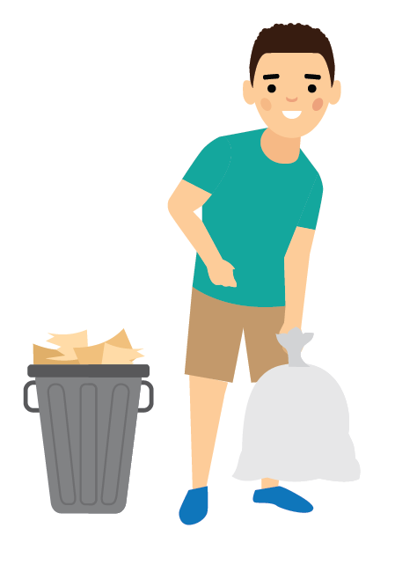
Dads play an important part in a healthy pregnancy.
You have a role in preventing infections for baby’s protection.

When David thought about his future and the dad he wanted to be, he made a commitment to himself to provide for his family as best he could. But as he talked with his healthcare provider, he was reminded that his commitment to his family starts even before his children are born. As a dad, he will contribute half of the biological building blocks for his children. Keeping himself healthy will help him pass along healthy genes and give his children their best chance at a healthy start.

Like David, you may be thinking about the family you may have one day. Here are some tips to help you prepare, get healthy and reduce the risk of infection for you and your partner.

- Properly prepare food.
  - Wash your hands before and after preparing food for you and your partner.
  - Do not serve raw or runny eggs or raw sprouts to your partner.
- Maintain good hygiene.
  - Wash your hands often with soap and water, especially
    - Before preparing or eating food
- After handling raw meat, raw eggs, or unwashed vegetables
- Protect yourself and your partner from animals and insects known to carry diseases such as Zika virus.
  - Change used cat litter so that your partner doesn’t have to touch it.
  - Use Environmental Protection Agency (EPA) registered insect repellents with one of the following active ingredients: DEET, picaridin, IR3535, or oil of lemon eucalyptus (para-menthane-3,8-diol). Help your partner spray or rub insect repellant into her skin.
  - If you have traveled to an area with Zika, use condoms correctly, every time you have vaginal, anal, or oral sex or do not have sex for the entire pregnancy.
- Talk to your healthcare provider.
  - Talk to your healthcare provider about what you can do to prevent infections, including sexually transmitted infections.
  - Talk to your healthcare provider about vaccinations (shots) that you and your partner should receive before and during the pregnancy.

Other ways to help prepare and get healthy.
  - Choose a healthy lifestyle.
    - Incorporate healthy eating and regular physical activity into your daily routine.
    - Take a multivitamin with 400 mcg of folic acid daily.
    - Talk to your healthcare provider about fertility, weight management, or other health issues.
  - Avoid harmful substances.
    - Protect yourself and your partner by quitting smoking and avoiding secondhand smoke and air pollution.
    - Do not drink excessively or use “street” drugs, such as cocaine or heroin.
  - Avoid harmful workplace exposures.
  - Ask questions about hazards in your workplace. You have a legal right to receive information on hazards in your workplace.
  - Learn how to avoid bringing hazards home on your skin, clothes, and shoes.

