Tools You Can Use | - Graphics  - Social Media Ideas
Graphics and animated GIFs, available on CDC website at https://www.cdc.gov/ncbddd/birthdefects/materials.html.
Tip ❶: Be sure to take 400 micrograms (mcg) of folic acid every day.
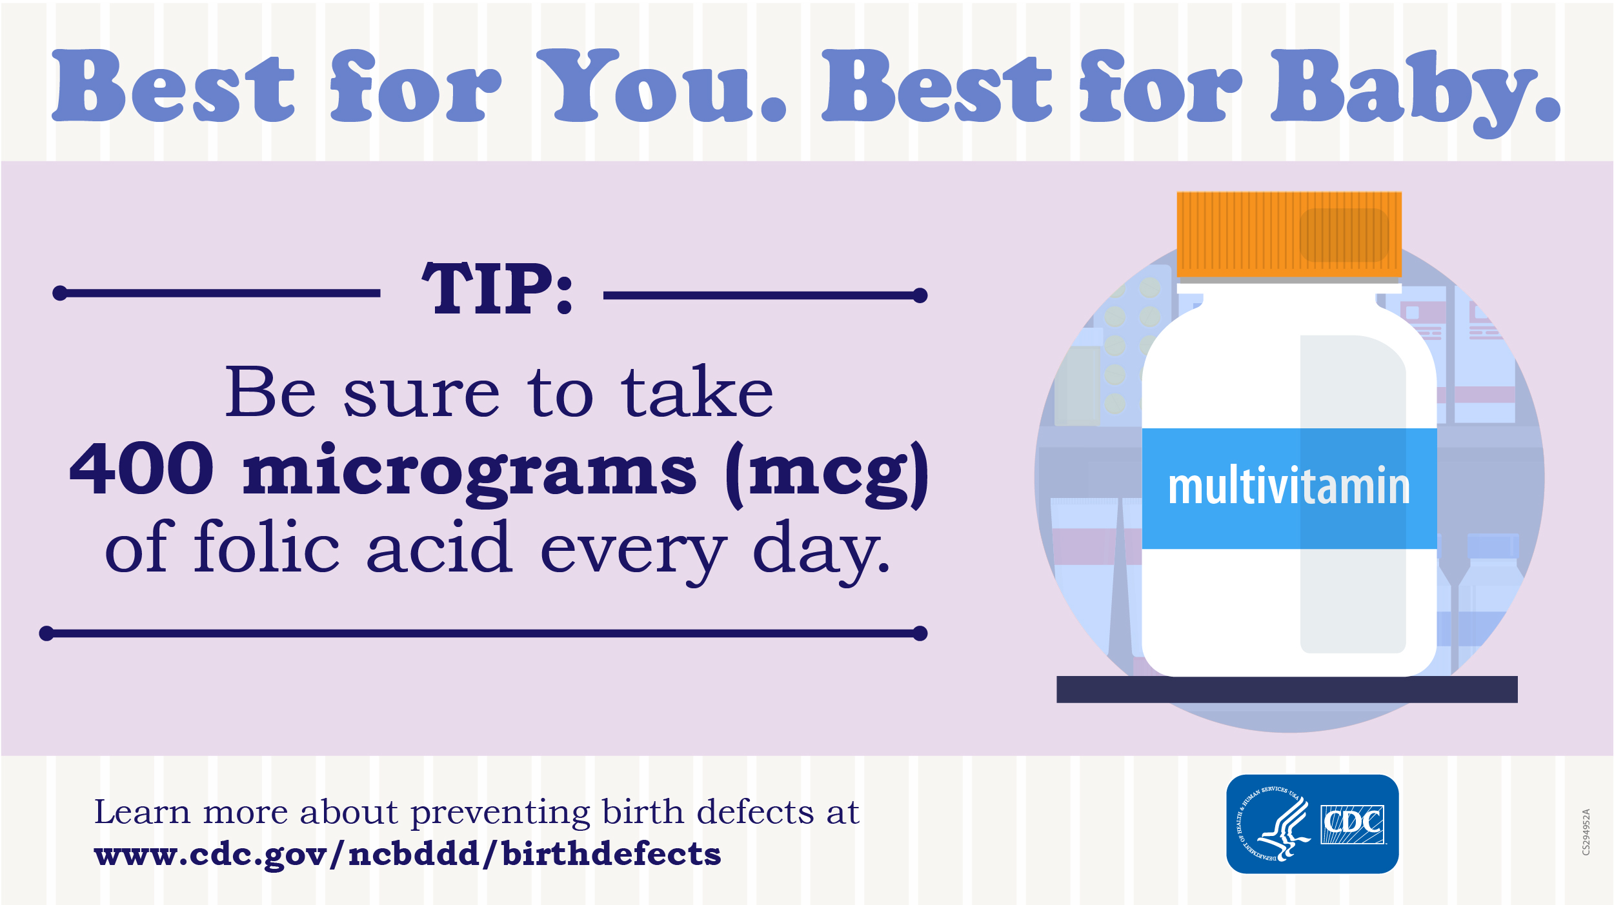

Tip ❷: Book a visit with your healthcare provider before stopping or starting any medicine.
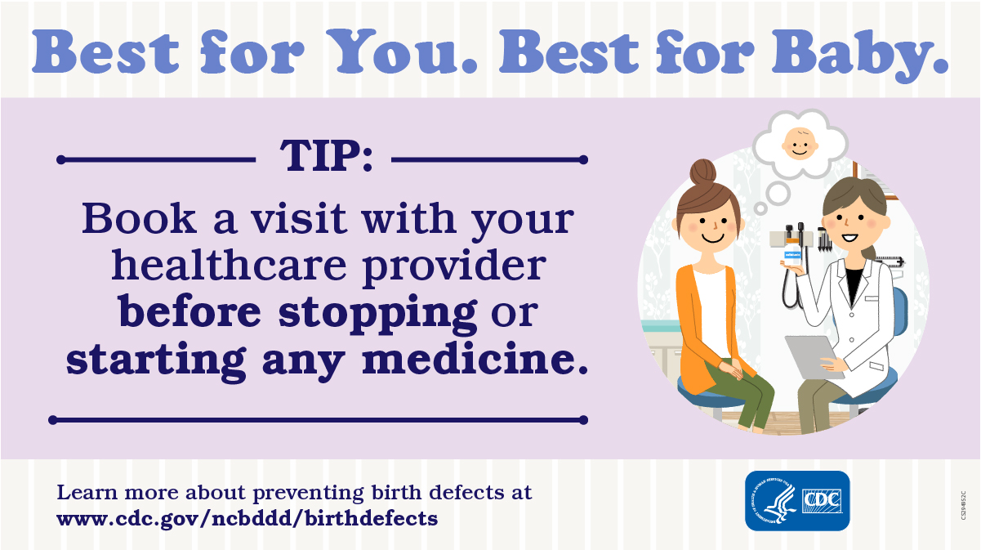

Tip ❸: Become up-to-date with all vaccines, including the flu shot.
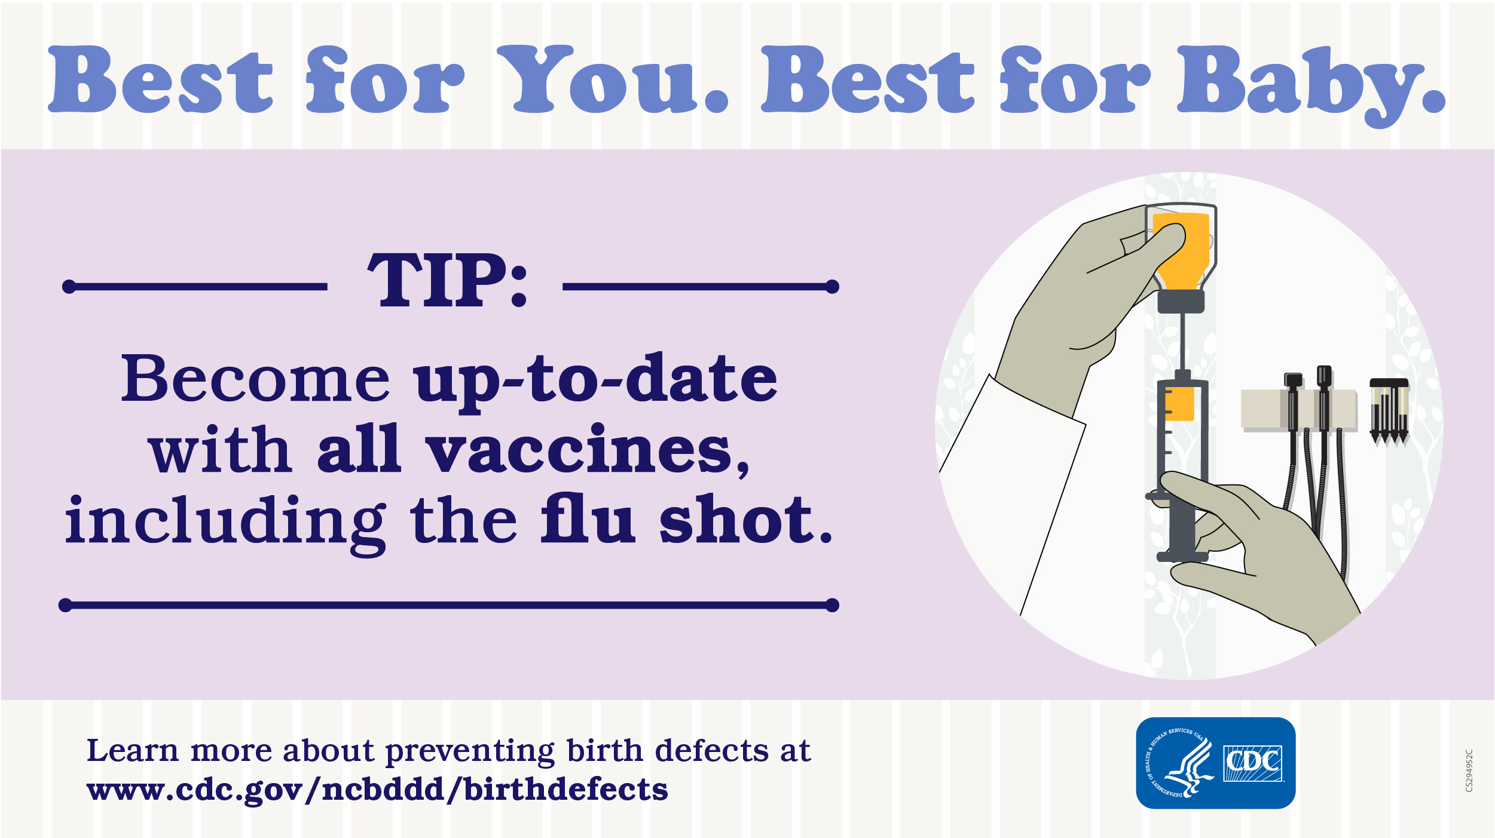

Tip ❹: Before you get pregnant, try to reach a healthy weight.
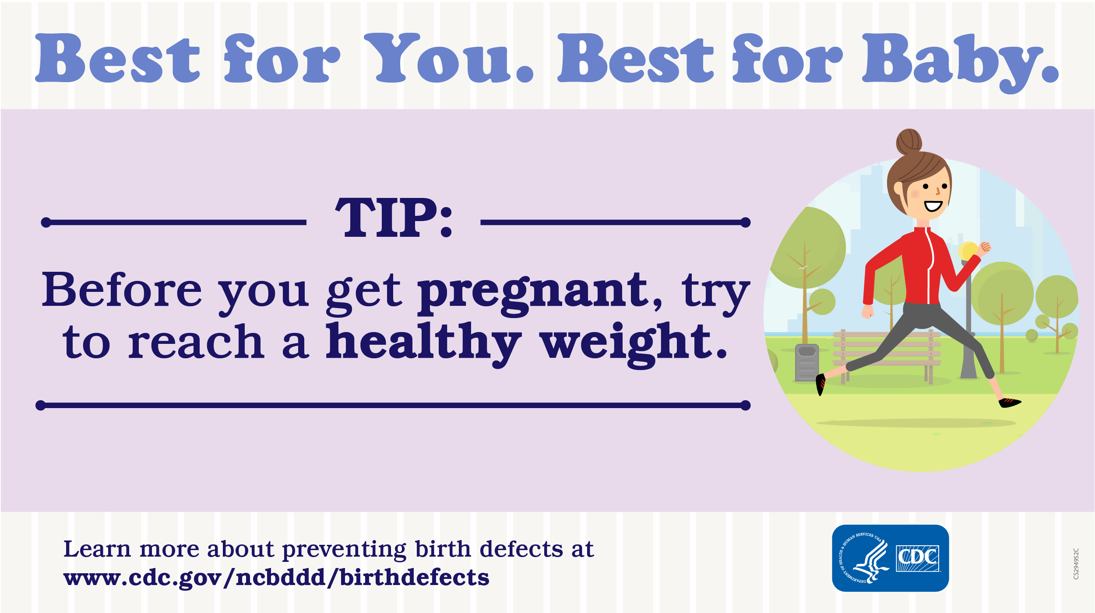

Tip ❺: Boost your health by avoiding harmful substances during pregnancy, such as alcohol, tobacco, and other drugs.

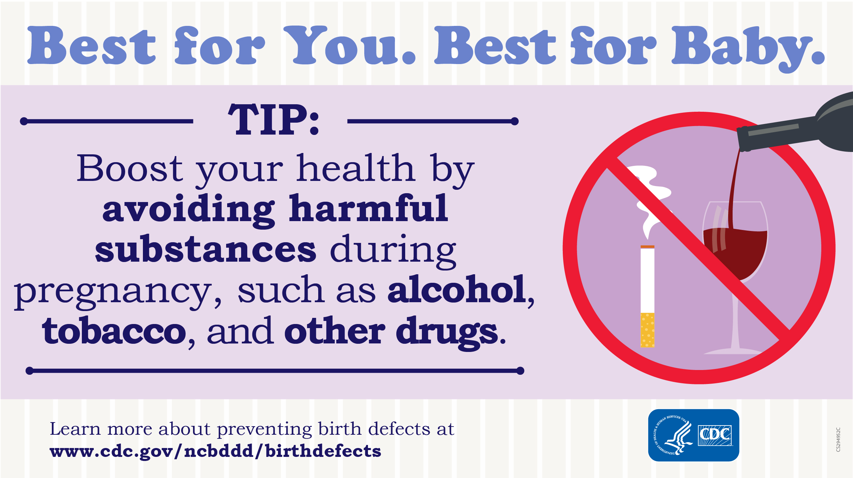

Social Media Engagement Idea
Use the "Best for You. Best for Baby." theme by encouraging “selfies” of women carrying out some of the theme tips for birth defects prevention.
Examples
Kerri posted:  I'm taking my prenatal vitamin every day because it's best for me and best for baby. What are you doing that's #Best4YouBest4Baby? Show it in a selfie! | Kara posted:  When I was pregnant, I frequently took my dog for a walk to not only get moving but also to get a little sunshine and fresh air. #Best4YouBest4Baby  