Materials Adapted for Local Public Health Department

This appendix contains some of the materials from the 2018 National Birth Defects Prevention Month packet that have been adapted for use in raising birth defects awareness with local public health agencies. These materials supplement a more comprehensive packet that includes a sample news release, proclamation, provider letters, resources on the internet, and parent resources.

Local public health resource packet includes examples of:
- LPH1: Local public health announcement
- LPH2: Traditional letter to local public health agency administrators
- LPH3: Electronic letter to local public health agency staff
- LPH4: Brief awareness article
- LPH5: Awareness article for public health clinic newsletters
- LPH6: Announcement for electronic newsletters or listservs

LPH1: Sample local public health announcement
Plan ahead for January 2018 – Birth Defects Prevention Month!
The theme for 2018 is “Prevent to Protect: Prevent Infections for Baby’s Protection”. We encourage you to begin thinking about activities you can do in your agency or community to raise public awareness of the role infection before and during pregnancy plays in the development of birth defects.
The National Birth Defects Prevention Network (NBDPN) has developed a valuable packet of information. The materials raise awareness among health and public health professionals as well as the general public and include posters, sample communication tools and resource sheets. Some ideas for use of the packet to raise awareness include:
  - Put posters up in your agency waiting rooms, even restrooms!
  - Provide fact sheets and posters on the importance of using folic acid to prevent certain types of serious birth defects.
  - Volunteer to present information on birth defects and birth defects prevention at a “lunch and learn” with your Maternal and Child Health (MCH) and Home Visiting Nurses and other agency staff.
  - Supply pamphlets or fact sheets for patients and professionals in doctors’ offices and clinics in the community.
Electronic materials will be sent as soon as they are ready. Please contact [Contact name] if you would like more information.
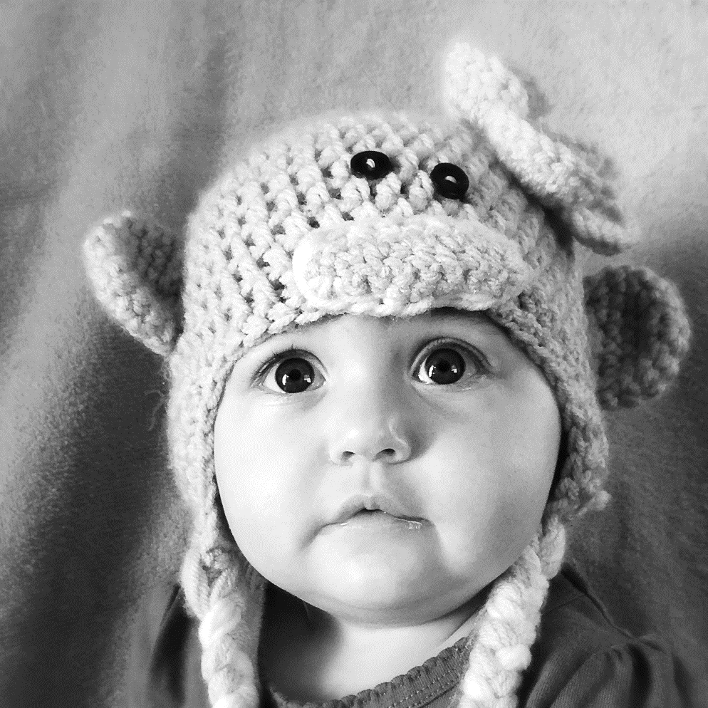
LPH2: Sample traditional letter to local public health agency administrators
January 2018
MEMORANDUM
TO: Administrators, County Health Departments
District Nurse Managers [Insert Other Recipients]

FROM: [Name]
[Title]

About 120,000 babies are affected by birth defects each year in the United States. In [State], approximately [###] babies are born with a birth defect each year. Not only can birth defects lead to lifelong challenges and disability, they are also the most common cause of death in infants and the second most common cause of death in children aged one to four years. I have included a state wide Birth Defects Profile for [State] (as well as a [Region] Birth Defects Profile) for your reference.

January is National Birth Defects Prevention Month. The theme for 2018 is “Prevent to Protect: Prevent Infections for Baby’s Protection”. We know that not all birth defects can be prevented. But, we also know that women can increase their chances of having a healthy baby by managing health conditions and adopting healthy behaviors before and during pregnancy. Some infections before and during pregnancy can hurt both you and your baby. They can cause birth defects and lifelong disabilities, such as hearing loss or learning problems. You can reduce your risk of getting an infection during pregnancy to help protect your baby by following the subsequent recommendations:
- Get vaccinated.
  - Get the flu shot and the whooping cough vaccine.
  - Become up-to-date with all vaccines before getting pregnant.
- Prevent insect bites.
  - Use insect repellent. Environmental Protection Agency (EPA) registered insect repellents with one of the following active ingredients: DEET, picaridin, IR3535, or oil of lemon eucalyptus (para-menthane-3,8-diol) is most effective.
- Wear long-sleeved shirts and long pants when outside.
- Consider avoiding travel to areas with Zika virus.
- Practice good hygiene.
- Wash your hands often with soap and water.
- Avoid putting a young child’s cup or pacifier in your mouth.
- Talk to your healthcare provider.
    - Ask about how you can prevent infections, such as Zika virus.
      - Discuss how to prevent sexually transmitted infections.

You can make a difference in the lives of [State] families. Please review the materials in the attached packet and use them to raise public awareness of birth defects. We invite you to share these resources with coworkers, colleagues, staff, and others who might benefit from this information.

Thank you for your support. If you have any questions or would like additional materials, please contact me or [Contact] by phone at [XXX-XXX-XXXX] or by email [Email].

LPH3: Sample electronic letter to local public health agency staff
Dear [public health nurses/practitioners/clinic staff/etc.],

The [name of state health department – hyperlinked to website] is joining the National Birth Defects Prevention Network (NBDPN) to raise awareness of birth defects and to promote strategies that reduce the risk of birth defects and their complications. The theme for 2018 is “Prevent to Protect: Prevent Infections for Baby’s Protection”. We hope that you will join us in promoting National Birth Defects Prevention Month and raising awareness of birth defects as a public health issue in your communities. Governor [name of Governor] has also proclaimed the month of January 2018 as Birth Defects Prevention Month [hyperlink to state proclamation]. I invite you to share the attached resources with coworkers, colleagues, local public health staff, and others who might benefit from this information.

Birth defects affect 1 in every 33 babies born in the United States and are a leading cause of infant mortality. Babies who survive and live with birth defects are at an increased risk for developing many lifelong physical, cognitive, and social challenges. Medical care and support services only scrape the surface of the financial and emotional impact of living with birth defects. We know that not all birth defects can be prevented. But, we also know that women can increase their chances of having a healthy baby by managing health conditions and adopting healthy behaviors before becoming pregnant. Please encourage all pregnant women and those who may become pregnant to:

- Get vaccinated.
  - Get the flu shot and the whooping cough vaccine.
  - Become up-to-date with all vaccines before getting pregnant.
- Prevent insect bites.
  - Use insect repellent. Environmental Protection Agency (EPA) registered insect repellents with one of the following active ingredients: DEET, picaridin, IR3535, or oil of lemon eucalyptus (para-menthane-3,8-diol) is most effective.
- Wear long-sleeved shirts and long pants when outside.
- Consider avoiding travel to areas with Zika virus.
- Practice good hygiene.
- Wash your hands often with soap and water.
- Avoid putting a young child’s cup or pacifier in your mouth.
- Talk to your healthcare provider.
    - Ask about how you can prevent infections, such as Zika virus.
      - Discuss how to prevent sexually transmitted infections.

The [name of state birth defects program – hyperlink to birth defects program website] website contains information, resources, and links to free educational materials from [name of state health department], the Centers for Disease Control and Prevention (CDC), and the National Birth Defects Prevention Network (NBDPN). We encourage you to use these materials to raise awareness of the ways birth defects can be prevented among health professionals and the general public in your community. You have the power to make a difference. We urge you to join us as an active participant in National Birth Defects Prevention Month - 2018 and to continue your efforts throughout the year.

LPH4: Sample awareness article (brief)
January is National Birth Defects Prevention Month
Prevent to Protect – Prevent Infections for Baby’s Protection
The [name of state/local] Department of Health is joining the National Birth Defects Prevention Network (NBDPN) and the [State] March of Dimes to raise awareness of birth defects and to promote strategies that reduce the risk of birth defects and their complications. Join us in promoting National Birth Defects Prevention Month!
Birth defects affect 1 in every 33 babies born in the United States and are a leading cause of infant mortality. Babies who survive and live with birth defects are at an increased risk for developing many lifelong physical, cognitive, and social challenges.
Although not all birth defects can be prevented, all women who could become pregnant or are pregnant can lower their risk of having babies with birth defects by following some basic health guidelines throughout their reproductive years. These include:
- Get vaccinated.
  - Get the flu shot and the whooping cough vaccine.
  - Become up-to-date with all vaccines before getting pregnant.
- Prevent insect bites.
  - Use insect repellent. Environmental Protection Agency (EPA) registered insect repellents with one of the following active ingredients: DEET, picaridin, IR3535, or oil of lemon eucalyptus (para-menthane-3,8-diol) is most effective.
- Wear long-sleeved shirts and long pants when outside.
- Consider avoiding travel to areas with Zika virus.
- Practice good hygiene.
- Wash your hands often with soap and water.
- Avoid putting a young child’s cup or pacifier in your mouth.
- Talk to your healthcare provider.
    - Ask about how you can prevent infections, such as Zika virus.
      - Discuss how to prevent sexually transmitted infections.

January is a perfect time to call additional attention to the importance of folic acid in preventing certain birth defects. The United States Public Health Service recommends that all women of childbearing age consume 400 micrograms (400mcg or .4mg) of folic acid daily to prevent up to 50 - 70% of neural tube defects, such as spina bifida and anencephaly.
The [name of State Birth Defects Program] has resource materials available on their website to assist you in raising awareness of birth defects as a public health issue in your clinic and communities. Materials include the NBDPN resource packet that can be tailored to meet your specific needs, sample partner and provider letters, a proclamation of the month, as well as links to resources for parents and other interested in learning more about birth defects.
For more information, contact [insert name and email]
LPH5: Sample awareness article for public health clinic newsletters
January is National Birth Defects Prevention Month
The [State] Department of Health is joining the National Birth Defects Prevention Network (NBDPN) to raise awareness of birth defects and to promote strategies that can reduce the risk of birth defects and their complications. This year’s theme is “Prevent to Protect: Prevent Infections for Baby’s Protection”. Although not all birth defects can be prevented, the healthcare community can help all women, including teens, who could become pregnant or are pregnant to lower their risk of having babies with birth defects by encouraging them to follow some basic health guidelines throughout their reproductive years:
- Get vaccinated.
  - Get the flu shot and the whooping cough vaccine.
  - Become up-to-date with all vaccines before getting pregnant.
- Prevent insect bites.
  - Use insect repellent. Environmental Protection Agency (EPA) registered insect repellents with one of the following active ingredients: DEET, picaridin, IR3535, or oil of lemon eucalyptus (para-menthane-3,8-diol) is most effective.
- Wear long-sleeved shirts and long pants when outside.
- Consider avoiding travel to areas with Zika virus.
- Practice good hygiene.
- Wash your hands often with soap and water.
- Avoid putting a young child’s cup or pacifier in your mouth.
- Talk to your healthcare provider.
    - Ask about how you can prevent infections, such as Zika virus.
      - Discuss how to prevent sexually transmitted infections.
January is a perfect time to call additional attention to the importance of folic acid in preventing certain birth defects. The United States Public Health Service recommends that all women of childbearing age consume 400 micrograms (400mcg or .4mg) of folic acid daily to prevent up to 50 - 70% of neural tube defects, such as spina bifida and anencephaly.
You can make a difference in the lives of [State] families. Additional resources can be found on the NBDPN website. If you have questions or would like more information, please contact [name and email].

LPH6: Sample announcement for electronic newsletters or listservs
January is National Birth Defects Prevention Month and January 7-13 is Folic Acid Awareness Week
The [name of state health department – hyperlinked to website] is joining the National Birth Defects Prevention Network (NBDPN) to raise awareness of birth defects and to promote strategies that reduce the risk of birth defects and their complications. We hope that you will join us in promoting National Birth Defects Prevention Month! This year’s theme is “Prevent to Protect: Prevent Infections for Baby’s Protection”. We know that not all birth defects can be prevented. However, we encourage all women to make healthy choices and adopt healthy habits to help lower their risk of having a baby born with a birth defect. Please encourage all pregnant women and those who may become pregnant to follow the recommended guidelines to reduce their chance of developing an infection before or during their pregnancy.
The [name of state birth defects program - hyperlink to birth defects program website] has resource materials available on their website to assist you in raising awareness of birth defects as a public health issue in your clinic and communities. Materials include the NBDPN resource packet and [State] resource packet that can be tailored to meet your specific needs. These materials contain sample partner and provider letters, a proclamation of the month, as well as links to resources for parents and other interested in learning more about birth defects and infections during pregnancy.
Folic Acid Awareness Week, January 7-13, is a perfect time to call additional attention to the importance of folic acid in preventing certain birth defects. The United States Public Health Service recommends that all women of childbearing age consume 400 micrograms (400mcg or .4mg) of folic acid daily to prevent up to 50 - 70% of neural tube defects, such as spina bifida and anencephaly. To learn more about Folic Acid Awareness Week go to http://www.nbdpn.org/faaw.php.
For more information, contact [name and email].

