● Fact Sheet for Policy Makers ●
Birth Defects Tracking, Research & Prevention
Tracking where and when birth defects occur and who they affect is a first step in preventing them. Tracking and research help us understand if the number of birth defects is increasing or decreasing over time, investigate possible causes, expand our understanding of preventive measures, and plan for health and education services for families of children with special needs.

Birth Defects: Common, Costly, and Critical

Common | Costly | Critical
1 in 33 babies | $2.6 billion | 1 in 5 deaths
Birth defects affect 1 in every 33 babies born in the United States. [Insert state numbers] | Each year, total hospital costs for U.S. children and adults exceed $2.6 billion. | Birth defects cause 1 in every 5 deaths among babies in their first year of life.
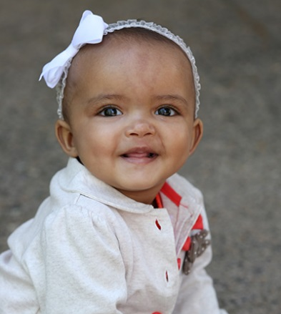
Real Families, Real Stories
Meet Renee. Renee represents 1 in every 33 babies born in the United States. She was diagnosed with spina bifida, a birth defect which affects the spine, shortly after birth. Initially the diagnosis was difficult to comprehend and prepare for. However, her mother Venesha moved forward and learned how to best care for Renee. Venesha says, “[Renee] continues to succeed despite her challenges with spina bifida. While she has spina bifida… it does not define her. She’s a firecracker—so determined and fearless.”

Importance of Birth Defects Tracking and Research
The value of birth defects tracking programs on clinical and public health research cannot be overstated. This work has revolutionized the way researchers, clinicians, and healthcare professionals approach, treat, and manage babies affected by birth defects. Tracking and research help us understand if the number of birth defects is increasing or decreasing over time, investigate possible causes, expand our understanding of preventive measures, and plan for health and education services for families of children with special needs. Identifying birth defects at a state level also strengthens public health officials’ ability to estimate prevalence and evaluate risk factors that are most important to their community.

[State] Birth Defects Tracking System
Since [year], the [Birth Defect Monitoring Program] has monitored the prevalence of birth defects in [State]. The [Birth Defect Monitoring Program] is a [“statewide” or indicate monitoring region], population-based surveillance program with information on approximately [###] babies born with specific birth defects. The [Birth Defect Monitoring Program] was established to identify and describe the patterns and trends of birth defects in [State], provide education and outreach, investigate potential causes, and respond to community concerns about possible clusters of birth defects. These data are essential for understanding the impact of birth defects in [State].

