● Educational Material for Men ●
Dads play an important part in a healthy pregnancy.
You have a role in preventing infections for baby’s protection.

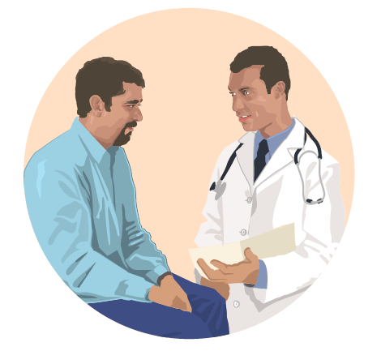
When David thought about his future and the dad he wanted to be, he made a commitment to himself to provide for his family as best he could. As he talked with his healthcare provider, he was reminded that his commitment to his family starts even before his children are born. Dads like David will contribute half of the biological building blocks for their children. Keeping himself healthy will help him pass along healthy genes and give his children their best chance at a healthy start.

Like David, you may be thinking about the family you may have one day. Here are some tips to help you prepare, get healthy and reduce the risk of infection for you and your partner.
  - Choose a healthy lifestyle.
    - Incorporate healthy eating and regular physical activity into your daily routine.
    - Talk to your healthcare provider about fertility, weight management, or other health issues.
  - Avoid harmful substances.
    - Protect yourself and your partner by quitting smoking and avoiding secondhand smoke and air pollution.
    - Do not drink excessively or use “street” drugs, such as cocaine or heroin.
  - Avoid harmful workplace exposures.
  - Ask questions about hazards in your workplace. You have a legal right to receive information on hazards in your workplace.
  - Learn how to avoid bringing hazards home on your skin, clothes, and shoes.

Help your partner prepare by reminding her take these steps:
- Get vaccinated.
  - Get the flu shot and the whooping cough vaccine.
  - Become up-to-date with all vaccines to protect yourself and your partner before trying to become pregnant.
- Protect yourself and your partner from insects known to carry diseases such as Zika virus.
  - When mosquitos are active wear long-sleeved shirts and long pants when outside.
  - Use Environmental Protection Agency (EPA) registered insect repellents with one of the following active ingredients: DEET, picaridin, IR3535, or oil of lemon eucalyptus (para-menthane-3, 8-diol). Help your partner spray or rub insect repellant into her skin.
  - Consider avoiding travel to an area with Zika virus.
- Practice good hygiene.
  - Wash your hands often with soap and water.
  - Avoid putting a young child’s cup or pacifier in your mouth.
- Talk to your healthcare provider.
  - Talk to your healthcare provider about what you can do to prevent infections, such as Zika virus.
  - Talk to your healthcare provider about how to prevent sexually transmitted infections.

